# Final Project Presentation YouTube Video Instructions

**Per Final Project requirements, all student’s final projects will be recorded via YouTube videos with YouTube links . Presentations will include narration of your project demonstration via slides and a demonstration of your technology.** You may record your screencast videos with any software of your choice.Information on downloading and installing free screencast software is below.

* **All students must submit as part of their Final Project a short video with YouTube links (2 minutes max).**
* Due to the large number of students we cannot organize public presentation of all student’s projects. We will select a small number of projects and ask the authors to present those projects to the whole class. Students who live in the Boston area are required to present in person. We will send a list of names & topics for Friday’s session to present. Students who do not live in the Boston area will be able to present over Canvas. The TAs will load your URLs. If your project is presented, you must be present online. **Every presentation is expected to last not more than 2+ minutes.**
* Do not waste too much time in your videos on things we learned in class and general glorification of Deep Learning. Speak about the details of the technology you have chosen to analyze or Case Study you are presented. Your short video is only 120 seconds long.
* Please do not forget to upload a ZIP file with working code organized in working directories and at least a sample datasets ( < 20MB).
* Please make sure that the URL pointing to the real dataset is publicly available.

**Making Screencast Video with ZOOM or OBS**

Camtasia, described below, places that strong "water mark" over your recording and sometimes that watermark is quite distracting. You can register with ZOOM, at https://zoom.us, and record videos for free.

OBS (https://obsproject.com/) as an amazing resource. OBD is available on all three main operating systems, and entirely free without watermarks. Nick thinks it’s by far the best.

**Making a Screencast Video for YouTube (see how to upload videos below)**

There are various screencast software packages available via free trials: Camtasia, SnapzProX, <http://camstudio.org/>, Snagit (<http://www.techsmith.com/snagit.html>) or Jing <http://www.techsmith.com/jing.html> , ScreenHunter Pro, HyperSnap, Ashampoo Snap). Below we describe one for Mac OsX and one for Windows but you are welcome to use any software you choose.

**For Windows Users: Camtasia**  
A free trial version of the Techsmith software [Camtasia](http://www.techsmith.com/camtasia.asp) will last for 30 days. Camtasia is an easy to use recording and editing suite, with splice and dice capabilities for screen captures into a final movie. Download and install the [Camtasia software](http://www.techsmith.com/camtasia.asp) from: https://www.techsmith.com/camtasia.html  
  
The best way to learn about Camtasia is to actually watch a couple of their [how-to videos](http://video.techsmith.com/camtasia/5/edu/quickstart/enu/default.html) on recording and editing. Experiment with the compression options for Quicktime when you produce you video to make sure the final video is as small as small as possible.

**For Mac Users: Quick Time or Snapz Pro X**  
If running MacOS X 10.x, you can use the new screencast feature of Quick Time X. More information is available at <http://www.makeuseof.com/tag/quick-screencasting-using-quicktime-x-in-mac-snow-leopard/>  
  
Or obtain a free trial of the Ambrosia software Snapz Pro X at: <http://www.ambrosiasw.com/utilities/snapzprox/> . This will last for 15 days or 100-uses whichever comes first. Snapz Pro X is relatively easy to use, but the trial version does not contain video editing software. Thus, once you record and compress your two-minute demo you can't make any changes unless you use some other sort of video editing software.  
  
Download the [SnapzProX software](http://www.ambrosiasw.com/utilities/snapzprox/) ( <http://www.ambrosiasw.com/utilities/snapzprox/> )and install SnapzProX in your Applications directory.  
  
Once you run SnapzProX the first time, it will always be running in the background on your machine, but no icon will appear in your icon tray. To start SnapzProX, press command+shift+3. A window like the image below will pop up.  
  
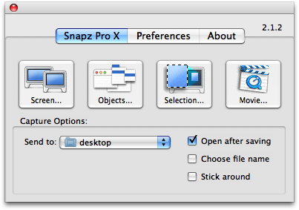  
  
Click the Movie button. Your desktop will dim, and a dashed-line rectangle will appear, along with the following window:  
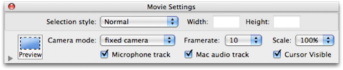  
  
In the window, select the microphone track if recording audio narration of your demo, and also select Mac audio track if demo includes sound. Also, make sure that the Camera mode is set to fixed camera so that the capture area remains fixed during recording. Drag the rectangle around and position over the part of your screen you want to capture. Adjust the size of the area. If your video is larger than 100MB, try selecting the scale to be 50% or 75%.  
When you are ready to start recording, press the enter key.  
Run your demo.  
When finished, press command+shift+3 again to stop recording. The following window will pop up:   
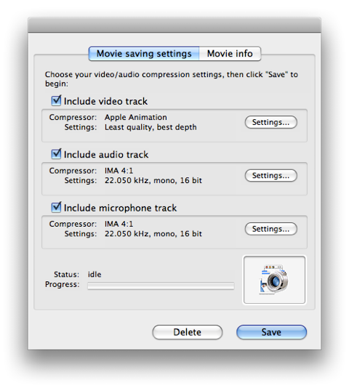  
Make sure to check the audio and microphone tracks if needed (or deselect). Experiment with the Video track settings to ensure that video file is smallest size possible. If you click on Settings under the Video track, you will get a window like this: 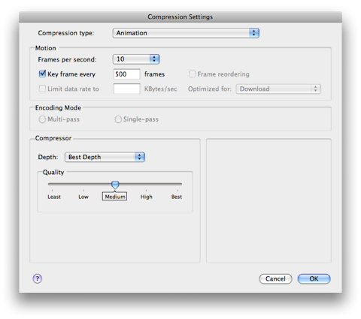  
  
Try different compression levels to see how compressed you can make your video without sacrificing the content.

## How to upload your YouTube videos

https://support.google.com/youtube/answer/57407?hl=en&topic=2888648&ctx=topic&rd=1

To get started uploading videos on YouTube, follow the steps below:

1. You need to create an account with YouTube using your email address.
2. Click the **Upload** link at the top of the page.
3. Select the video you'd like to upload from your computer.

Once the upload is completed, YouTube will send you an email to notify you that your video is done uploading and processing.

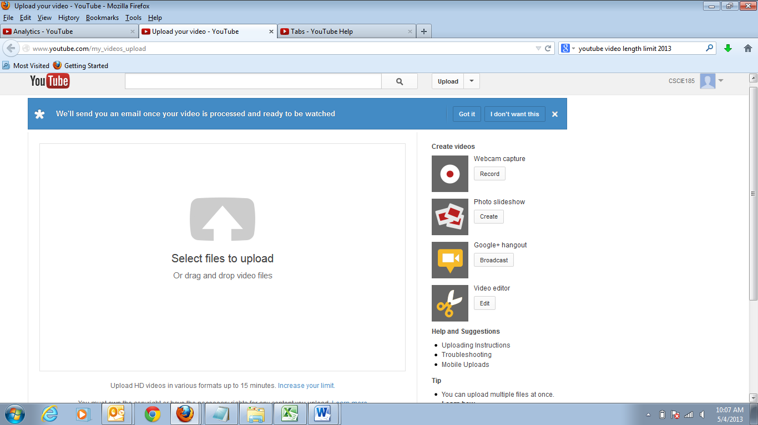

Pull down menu, with options for:

“Dashboard”,

“Video Manager”,

“Analytics”

Set Channel to:

CSCI-S89a Your Name

Make sure that you’re using one of the following formats:

* .MOV
* .MPEG4
* .AVI
* .WMV
* .MPEGPS
* .FLV
* 3GPP
* WebM

## Set default upload settings

1. Go to your Settings page by clicking your **name** in the upper right of the page, then **Settings**
2. In the Settings menu on the left side of the page, click **Defaults**
3. Use the defaults menu to set your defaults. Options that can be defaulted are privacy, category, title, license, tags, suggested edits, and more
4. Click **Save**

Now when you upload a video, you'll see the default fields pre-set according to your choices.

You’ll still be able to change settings after you upload.

Everyone with a YouTube account also has their very own YouTube Channel. Your YouTube Channel is a personalized home for:

* the videos you’ve uploaded.
* broadcasts of playlists you have created.
* your YouTube activities: likes, favorites, subscriptions, comments.
* the information about your Channel that you’d like to share: About This Channel, social links, and linked websites.

You can find more information on your Channel in our [Channels Design Getting Started Guide](http://support.google.com/youtube/bin/static.py?hl=en&guide=1734705&topic=1735163&page=guide.cs).

In the Info and Settings tab, you can customize your Channel’s Title, Description, Tags, and also set which tab users will see by default when they visit your Channel.

You can set channel to CSCI-S89a Your Student Name

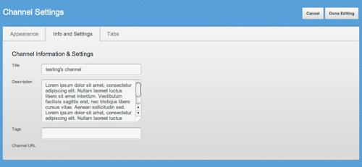

Make sure to give your Channel a **name and description** that make sense. We will use this name and description wherever your Channel is found on YouTube, and they are also displayed in the “About” section on your Channel. The title you choose will be shown at the top of your Channel, next to your Avatar, so make it good! The character count of the Channel description is **1,000 characters**, but only 250 characters will be exposed by default in the "About" section, with the remainder available behind a "more" link. Be sure to write concise and useful descriptions; this shortened version of this description will also appear across the site.

**Set Channel Name = CSCI-S89a Your Student Name**

**Set Channel Description = 2019 S89a Final Project – Topic title here**

Verify Your YouTube Account